Pages
- Main Menu
- Dataset Interface Page
- Local File Upload Page
- Graph and Export Page

Main Menu
- Components
  - Radio Buttons
    - “MongoDB Cluster Connection String”
      - Users can select this which makes the Java Connection String text field and the Connect button visible.
    - “CSV file”
      - Users can select this which makes the “Upload Files” button visible.
  - Text Field
    - “Java Connection String”
      - Initially not visible until the appropriate radio button is selected.
  - Button
    - “Connect”
      - Initially not visible until the appropriate radio button is selected.
      - Opens the Dataset Interface page if the connection string entered connects to a database, otherwise outputs the appropriate message to the user in the Notification Output.
    - “Upload Files”
      - Initially not visible until the appropriate radio button is selected.
      - Opens the Local File Upload Page.
  - Text Area
    - “Notification Output”
      - This is where any mistakes in the connection to the database are reported.
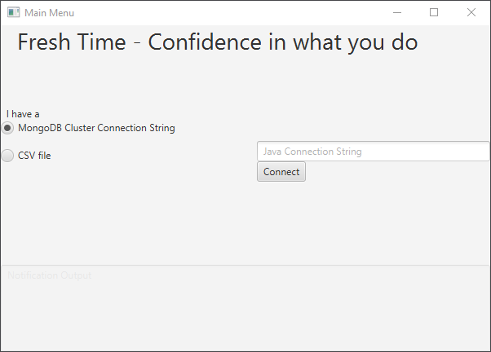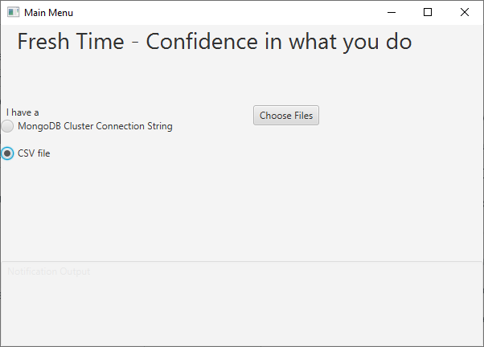

The Main Menu reflects the following use cases:
- Users are able to connect to their existing MongoDB database using the java connecting string.
- Users are able to select options between the database architecture that are supported.

Dataset Interface Page
- Components
  - Label
    - “Connected to”
      - Information from the cluster provided on the main menu will be displayed here.
  - Text Field
    - “Database Name”
      - Text entry is required for connection to the database using the cluster information provided on the Main Menu.
    - “Restaurant Collection Name”
      - Text entry is required for connection to the collection that contains correctly formatted restaurant information from MongoDB.
    - “Area of Service Collection Name”
      - Text entry is required for connection to the collection that contains correctly formatted areas of service information from MongoDB.
  - Button
    - “Upload Data”
      - This button pulls the data and will display the parsed data to the restaurants list view and area of service locations list view respectively.
    - “Run Mapping Algorithm”
      - This button is disabled until Upload Data is run successfully and the results are displayed.
      - Opens the Graph and Export page.
    - “Start Over”
      - Returns the user to the main menu
  - List View
    - “Restaurants”
      - Restaurants that can be parsed from the collection will be shown here.
    - “Area of Service Locations”
      - Predicted long lat in the area of service are displayed here.
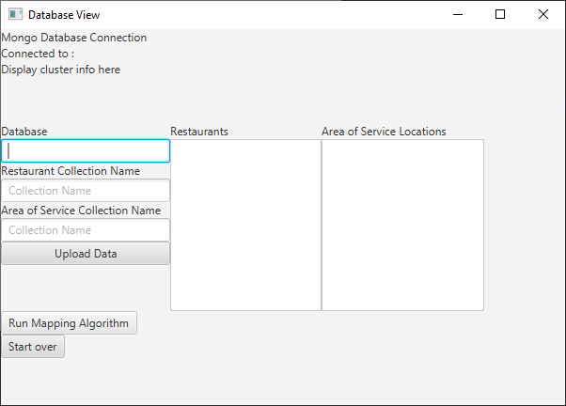

The Dataset Interface Page reflects the following use cases:
- Users are able to specify the database and collection of the area of service they are provided and the collection of restaurants they are servicing and upload this data to our client.
- Users are able to see their data visually through our client.

Local File Upload Page
- Components
  - Button
    - “Upload Restaurants File”
      - Opens a file explorer to select a correctly formatted txt file from the users local system which should contain the restaurants FreshFood will be servicing.
    - “Upload Area of Service File”
      - Opens a file explorer to select a correctly formatted txt file from the users local system which contains the points for area of service.
    - “Run Mapping Algorithm”
      - This button is disabled until both files are uploaded and correctly parsed and the results are displayed.
      - Opens the Graph and Export page.
    - “Start Over”
      - Returns the user to the main menu.
  - List View
    - “Restaurants File”
      - Displays the parsed restaurants from the restaurant file.
    - “Area of Service File”
      - Displayed the parsed locations from the area of service file.

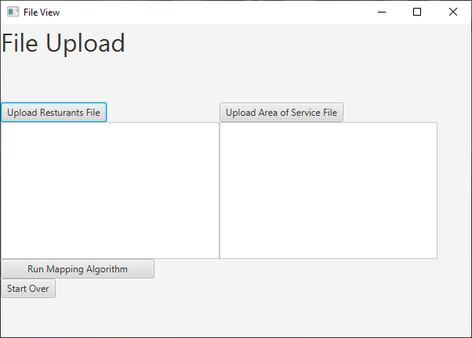
The Local File Upload page reflects the following use cases:
- Users are able to upload a local file from their system.
- Users are able to see their data visually displayed.

Graph and Export Page
- Components
  - Image View
    - “Graph”
      - This is where a graph will be displayed if applicable which will display on the x axis the number of drivers, and on the y axis will be the average wait time per customer as the number of drivers increases.
  - Button
    - “Export”
      - Will create a png file with the graph or export a txt file with the data.
    - “Go Back”
      - Will bring the user back to either the file upload page or the dataset interface page.
    - “Start Over”
      - Will bring the user back to the main menu.
  - Radio Button
    - Specified which data to requested to be exported by the export button.
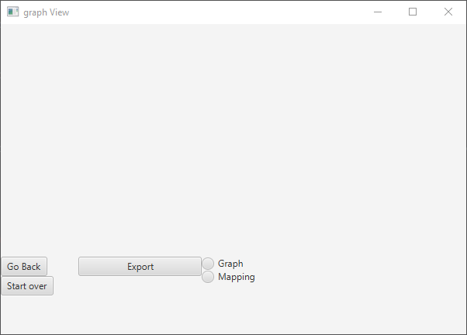
This page supports the following use cases:
- Users are able to export graphs or the raw data mapping from the algorithm.
- Users are able to repeat the experiment with other datasets.
- Users are able to see the algorithm output data visually.

